

CAPSTONE PROJECT REPORT
Report 3 – Project Overview

– Ho Chi Minh, October 2026 –
Table of Contents
I. Record of Changes 3
II. Project Overview 4
1. Overview 4
1.1 Project Information 4
1.2 Project Team 4
2. Product Background 4
2.1 Product Vision 4
2.2 Product Scope 4
2.5 System Context Diagram 5
3. User Requirements 6
3.1 User Roles 6
3.2 User Requirements – Administrator 6
3.3 User Requirements – Farm Operator 7
3.4 User Requirements – Customer 7
3.5 User Requirements – Shipper 8
3.6 Non-Functional Requirements 8
3.7 System Use Case Diagram 9
4. System Functional Overview 10
4.1 Screens Flow 10
4.2 System Architecture 11
4.3 Functional Modules 11
4.4 System Functional Flows 12
4.5 System Data Overview 13
4.6 System Constraints & Dependencies 13

I. Record of Changes
Date | A*  M, D | In charge | Change Description
*A - Added M - Modified D - Deleted

II. Project Overview

1. Overview

1.1 Project Information
- Project name: Building a Smart Mushroom Cultivation Management System with Rental and Remote Monitoring Features.
- Group Code: GFA26SE30
- Project code: FA26SE123
- Group name: SEP490_GFA26SE30
- Software type: Web Application, Mobile Application, IoT System.
- Main technologies: Node.js (ExpressJS), PostgreSQL, RESTful API, React (TypeScript, Vite, Ant Design, Zustand), ESP32-S3 (Gateway Master), STM32 (RS485 Slave Nodes), environmental sensors, and camera devices.

1.2 Project Team
Full Name | Role | Email | Mobile
Lê Nguyễn Xuân Khôi | Leader | khoilnxse183384@fpt.edu.vn | 0379896749
Trần Anh Tú | Member | tutase183396@fpt.edu.vn | 0931330034
Võ Thanh Tòng | Member | tongvtse182169@fpt.edu.vn | 0767413990
Nguyễn Phi Khanh | Member | khanhnpse183527@fpt.edu.vn | 0707935694
Thân Trần Quốc Huy | Member | huyttqse183533@fpt.edu.vn | 0355641118

2. Product Background

2.1 Product Vision
- MCMS is a smart mushroom cultivation management system that integrates tray rental, remote monitoring, IoT environmental sensing, automated environmental control, camera monitoring, notifications, and harvest management. The system serves four roles: Administrator, Farm Operator, Customer, and Shipper. The goal is to provide a transparent and interactive cultivation experience for customers while improving operational efficiency and environmental monitoring for farm operators.

2.2 Product Scope
- In-scope: Mobile app for Customers (tray rental, remote monitoring); Web app for Admin & Farm Operator (user, room, tray, package, environment, camera, and harvest management); IoT sensors (temperature, humidity); control devices (mist sprayers, fans, LED lights, heaters); camera monitoring; notifications; historical data storage; Shipper delivery workflow.
- Out-of-scope: Third-party logistics integration; advanced route optimization; fleet management; multiple distributed farms; non-mushroom crops; agricultural marketplace; enterprise accounting; external agricultural system integration; advanced AI (disease detection, production forecasting).
2.3 Product Components
# | Component | Description
1 | IoT Hardware & Environmental Automation | ESP32-S3 Gateway Master + STM32 RS485 Sub-nodes + sensors (temp, humidity) + actuators (mist, fan, LED, heater)
2 | Backend RESTful API & Database | Node.js (ExpressJS) + PostgreSQL + RBAC for 4 roles
3 | Web Management Portal | React (TypeScript, Vite, Ant Design, Zustand) for Administrator & Farm Operator
4 | Customer & Shipper Mobile App | Flutter for Customer & Shipper

2.4 Major Features
Role | Main Features
Administrator | Manage users, rooms, trays, packages, IoT devices, cameras; view statistics/reports; configure thresholds & notifications; export data
Farm Operator | Manage rooms/trays; assign trays to customers; monitor temp/humidity; control devices; manage cameras; update progress; manage harvests; receive alerts
Customer | Register/sign in; view/update profile; browse & rent trays/packages; register tray via code; view tray details; monitor environment; view camera; receive notifications; view history; request harvest/delivery
Shipper | Sign in; view assigned orders; view customer/delivery info; confirm pickup; update delivery status; confirm successful delivery
System | Collect sensor data, automate control, send notifications, store historical records, and provide RESTful APIs.

2.5 System Context Diagram
The high-level interactions and data flows between the Smart Mushroom Cultivation Management System (MCMS) and external actors/entities are illustrated in Figure 1 below.
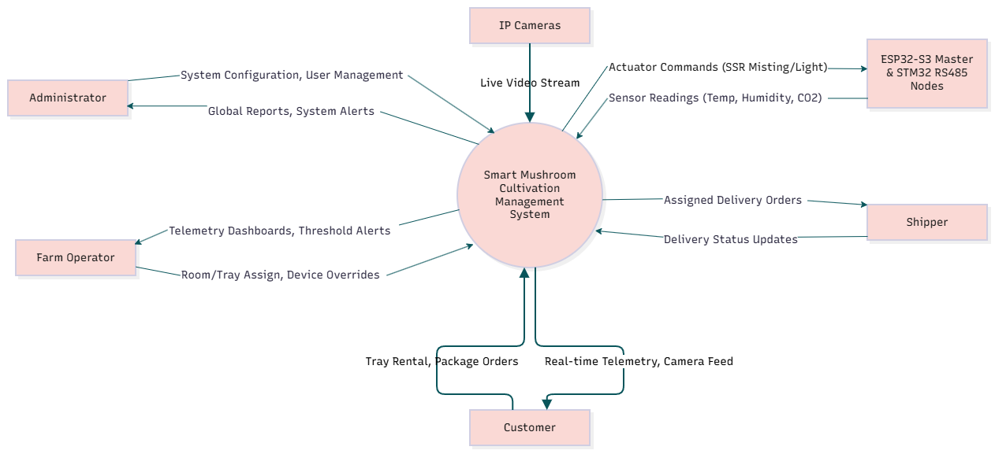
Figure: System Context Diagram for MCMS.
As shown in the figure, the central system interacts with five primary external entities:
- Administrator & Farm Operator: Issue system configuration, room/tray assignments, and manual device overrides while receiving real-time telemetry, system alerts, and analytics reports.
- Customer: Submits tray rental requests, tracks cultivation progress, views real-time telemetry/live camera streams, and requests harvests.
- Shipper: Receives assigned delivery orders and updates delivery execution statuses.
- ESP32-S3 Gateway & STM32 RS485 Nodes: Transmit environmental sensor data (temperature, humidity) to the backend and receive actuator execution commands (SSR misting, lighting, heating).
- IP Camera Devices: Provide live video streaming feeds directly to the client interfaces.

3. User Requirements

3.1 User Roles
Role | Description | Interface
Administrator | System administrator with full access | Web
Farm Operator | Daily farm operations staff | Web
Customer | Rent trays and monitor remotely. | Mobile
Shipper | Delivery personnel | Mobile
System | Automated actor (data collection, control, notifications)

3.2 User Requirements – Administrator
ID | Requirement | Priority
AD-01 | Sign up and sign in securely. | High
AD-02 | CRUD user accounts (all roles) | High
AD-03 | CRUD cultivation rooms | High
AD-04 | CRUD cultivation trays & assign to rooms | High
AD-05 | CRUD rental packages & pricing | High
AD-06 | Register, configure, and monitor IoT devices, sensors, cameras | High
AD-07 | View statistics & reports (environment, rental, harvest). | Medium
AD-08 | Export data & reports | Medium
AD-09 | Configure notifications & environmental thresholds. | High

3.3 User Requirements – Farm Operator
ID | Requirement | Priority
FO-01 | Sign in securely. | High
FO-02 | Manage rooms & trays. | High
FO-03 | Assign trays to customers. | High
FO-04 | Monitor temp, humidity in real time. | High
FO-05 | Control misting, ventilation, and environmental devices. | High
FO-06 | Manage cameras & streams. | Medium
FO-07 | Update cultivation progress & tray status. | High
FO-08 | Manage harvest schedules & records. | High
FO-09 | Receive environmental alerts. | High
FO-10 | View sensor history & device status | Medium

3.4 User Requirements – Customer
ID | Requirement | Priority
CU-01 | Register a new account. | High
CU-02 | Sign in securely. | High
CU-03 | View/update profile | Medium
CU-04 | Browse trays & rental packages. | High
CU-05 | Rent one or multiple trays. | High
CU-06 | Register the tray using a unique tray code. | High
CU-07 | View tray details, stage, status, and expected harvest date. | High
CU-08 | Monitor temp, humidity of rented trays. | High
CU-09 | Access live camera feeds. | High
CU-10 | Receive notifications (cultivation, environment, harvest). | High
CU-11 | View rental history & transactions. | Medium
CU-12 | Request harvest collection/delivery. | High

3.5 User Requirements – Shipper
ID | Requirement | Priority
SH-01 | Sign in securely. | High
SH-02 | View assigned delivery orders. | High
SH-03 | View customer & delivery information. | High
SH-04 | Confirm pickup from the farm. | High
SH-05 | Update delivery status (assigned → picked up → delivering → delivered). | High
SH-06 | Confirm successful delivery. | High

3.6 Non-Functional Requirements
ID | Category | Requirement
NFR-01 | Performance | Real-time data delay ≤ 2 seconds
NFR-02 | Performance | Support ≥ 50 concurrent users
NFR-03 | Reliability | Uptime ≥ 99.5%
NFR-04 | Security | Authentication using JWT, password hashing
NFR-05 | Security | RBAC is enforced on all APIs & UI routes.
NFR-06 | Usability | Mobile app usable by average smartphone users
NFR-07 | Usability | Web portal with clear dashboards & visual indicators
NFR-08 | Compatibility | Mobile supports Android.
NFR-09 | Compatibility | Web supports Chrome, Firefox, Edge, and Safari.
NFR-10 | Maintainability | Code follows conventions, managed via Git Flow.
NFR-11 | Scalability | Easy to add rooms, trays, IoT devices
NFR-12 | Data Integrity | Reliable storage & retrieval of historical data

3.7 System Use Case Diagram
The detailed functional interactions between system actors and core use cases, including authentication dependencies (<<include>>), are depicted in Figure
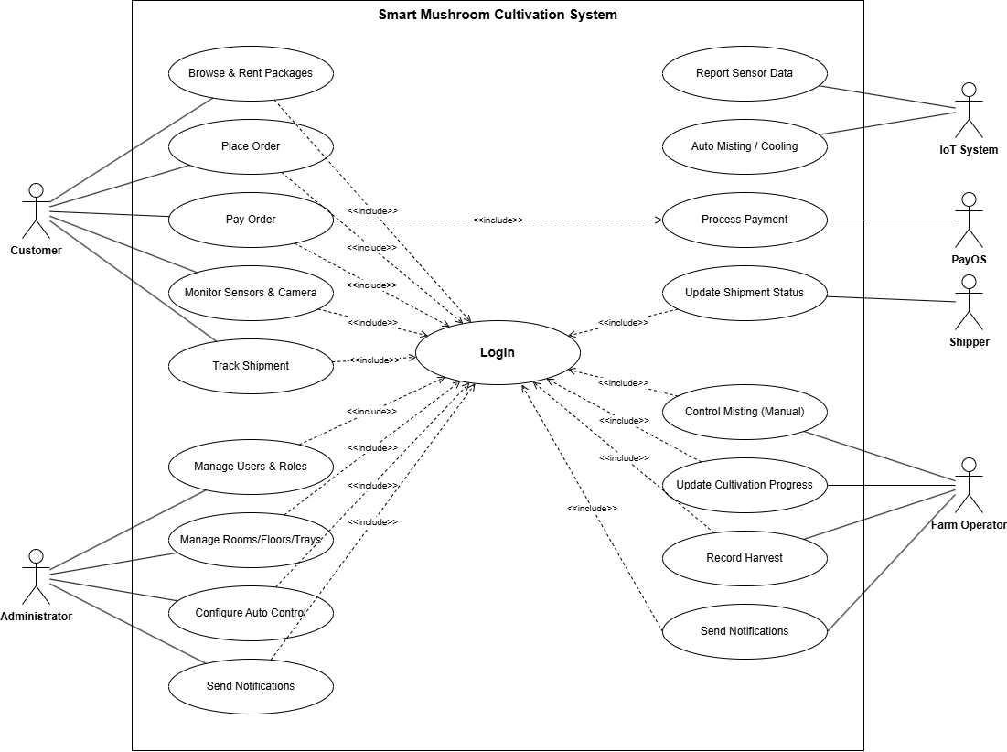
Figure: System Use Case Diagram.
Figure illustrates the functional scope mapped to each specific system actor:
- Administrator: Configures users, roles, cultivation rooms, floors, trays, IoT parameters, and views global reports.
- Farm Operator: Executes daily farm tasks, including room/tray monitoring, manual/automatic device control, progress updates, and harvest recording.
- Customer: Browses rental packages, rents trays, monitors real-time environmental metrics and live camera streams, and requests harvest delivery.
- Shipper: Receives assigned deliveries and confirms status updates.
- IoT System & PayOS: Automated external system actors for telemetry logging, auto-misting control, and payment gateway processing.
- All primary functional use cases explicitly incorporate (<<include>>) the central Login use case to enforce secure Role-Based Access Control (RBAC).

4. System Functional Overview

4.1 Screens Flow
The navigation hierarchy and screen transition flows across the Web Management Portal and Mobile App interfaces are structured in Figure
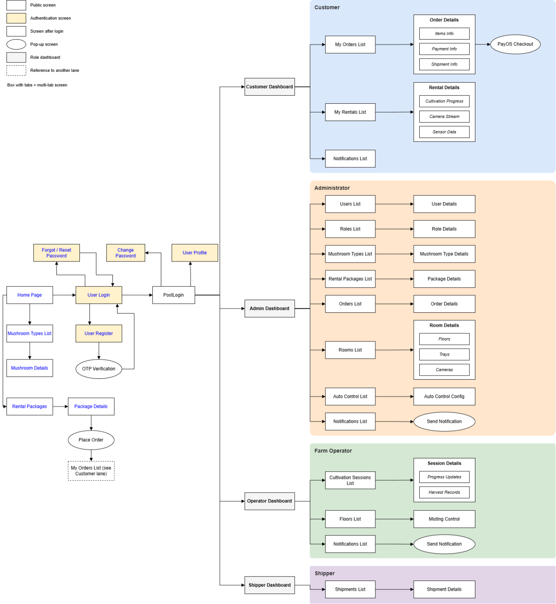
Figure: Web Management Portal and Mobile App Screens Flow.
The screen layout flow is divided into two primary client interfaces following successful user authentication:
- Web Management Portal (Admin & Farm Operator): Navigates from the primary Dashboard Overview into dedicated modules including Room/Floor/Tray Management, IoT Hardware & Auto Control Configs, Harvest Schedule Management, and Analytics Reports.
- Mobile Application (Customer & Shipper): Directs users from the App Home Screen to Package Browsing/Checkout, Rented Tray Monitoring (Live Sensor Graphs & IP Camera Stream), and Delivery Management views for shippers.

Layer | Components | Role
IoT Layer | ESP32-S3 (Master Gateway), STM32 (RS485 Nodes), sensors, actuators, cameras | Collect data & execute commands
Backend Layer | Node.js API, PostgreSQL, notification service | Process logic, store data, RBAC, and provide APIs
Client Layer | ReactJS (TypeScript, Vite, AntD) Web Portal, Flutter Mobile App | User interfaces for all roles
Integration Layer | RESTful APIs, telemetry, camera streaming | Connect IoT – backend – clients.

4.2 System Architecture
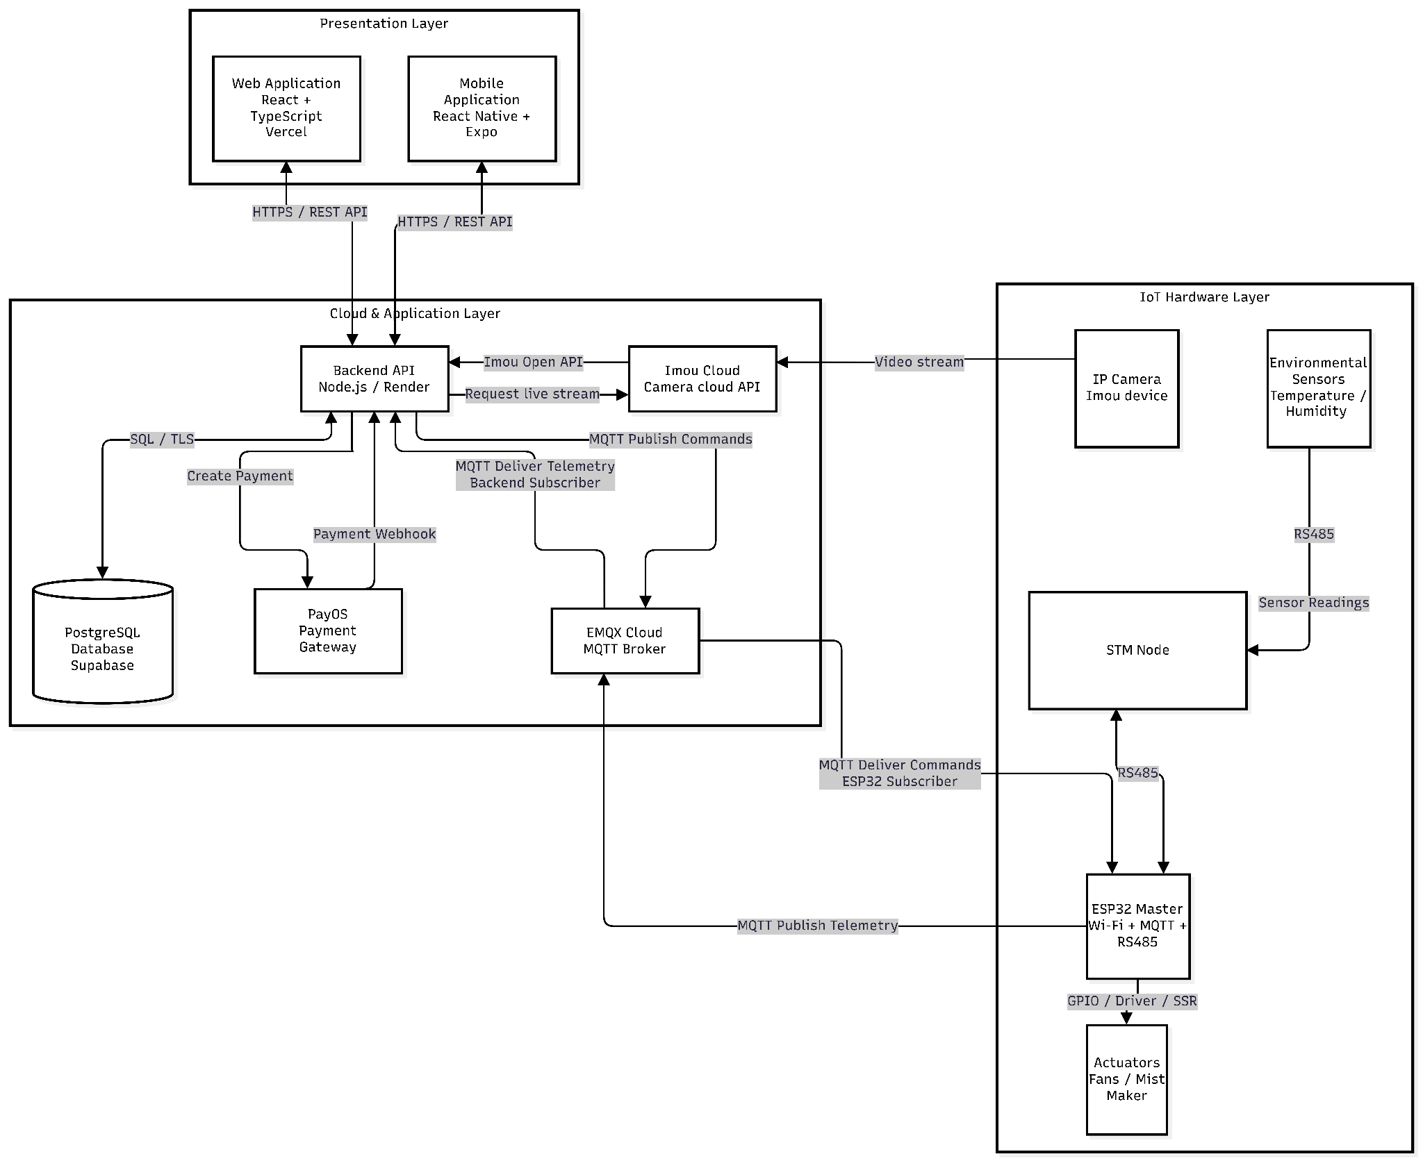

4.3 Functional Modules
Module | Main Functions | Roles
User & Access Management | Registration, authentication, profile, user admin, RBAC | All, Admin
Cultivation Room & Tray Management | CRUD rooms/trays, assign trays, register tray by code, track status | Admin, Farm Operator, Customer
Rental & Package Management | CRUD packages, browse, rent trays, view history | Admin, Customer
Environmental Monitoring | Collect sensor data, real-time monitoring, sensor history, threshold config, alerts | System, Admin, Farm Operator, Customer
Environmental Control | Automated & manual device control, device management, device status | System, Farm Operator, Admin
Camera Monitoring | Manage cameras, view live feed | Admin, Farm Operator, Customer
Notification | Environmental alerts, milestones, harvest readiness, configuration | System, Farm Operator, Customer, Admin
Harvest Management | Manage harvest schedules & records, update progress, request harvest | Admin, Farm Operator, Customer
Delivery & Shipper | Assign orders, view orders, confirm pickup, update status, confirm delivery | Admin, System, Shipper
Reporting & Analytics | Cultivation statistics, environment/rental/harvest reports, export data | Admin

4.4 System Functional Flows
# | Flow | Actors
1 | Registration & Authentication – Register/sign in, assign role-based access | All
2 | Tray Rental – Browse → select tray → rent → confirm → assign tray | Customer, Admin, Farm Operator
3 | Tray Registration – Enter tray code → validate → link to account | Customer, System
4 | Environmental Monitoring – Sensors → backend → display on web/mobile → alerts if threshold exceeded | System, Farm Operator, Customer
5 | Automated Control – Sensor exceeds threshold → trigger actuator → adjust environment | System
6 | Manual Control – Operator views dashboard → manually controls → command sent to IoT | Farm Operator, System
7 | Camera Monitoring – Camera stream → backend relay → user views live feed | Customer, Farm Operator, System
8 | Notification – System detects event → sends notification → user receives alert | System, Customer, Farm Operator
9 | Harvest – Operator updates progress → harvest ready → Customer requests → schedule & record | Farm Operator, Customer, System
10 | Delivery – Customer requests → assign Shipper → pickup → deliver → confirm | Customer, Shipper, Admin, System
11 | Reporting – Admin accesses → system aggregates → display/export | Admin, System

4.5 System Data Overview
Entity | Key Attributes
User | User ID, name, email, phone, role, password hash, status
Cultivation Room | Room ID, name, location, capacity, status
Cultivation Tray | Tray ID, unique code, room ID, status, stage, assigned customer
Rental Package | Package ID, name, description, price, duration
Rental Record | Rental ID, customer ID, tray ID, package ID, dates, status
Environmental Record | Record ID, room ID, temp, humidity, timestamp
IoT Device | Device ID, type, room ID, status, config
Camera | Camera ID, room ID, stream URL, status
Notification | Notification ID, user ID, type, message, timestamp, read status
Harvest Record | Harvest ID, tray ID, scheduled date, actual date, yield, status
Delivery Order | Order ID, customer ID, shipper ID, pickup, delivery address, status, timestamps

4.6 System Constraints & Dependencies
# | Constraint / Dependency
1 | Stable Internet required for remote monitoring & control
2 | Data accuracy depends on sensor quality.
3 | Camera quality depends on hardware & bandwidth.
4 | IoT control may experience delays due to network/device communication.
5 | Delivery status depends on the Shipper updating correctly.
6 | The system does not fully replace Farm Operator decisions.
7 | The PCB fabrication (ESP32-S3 Gateway & STM32 RS485 Nodes) and hardware assembly timeline directly affect the overall project schedule.

